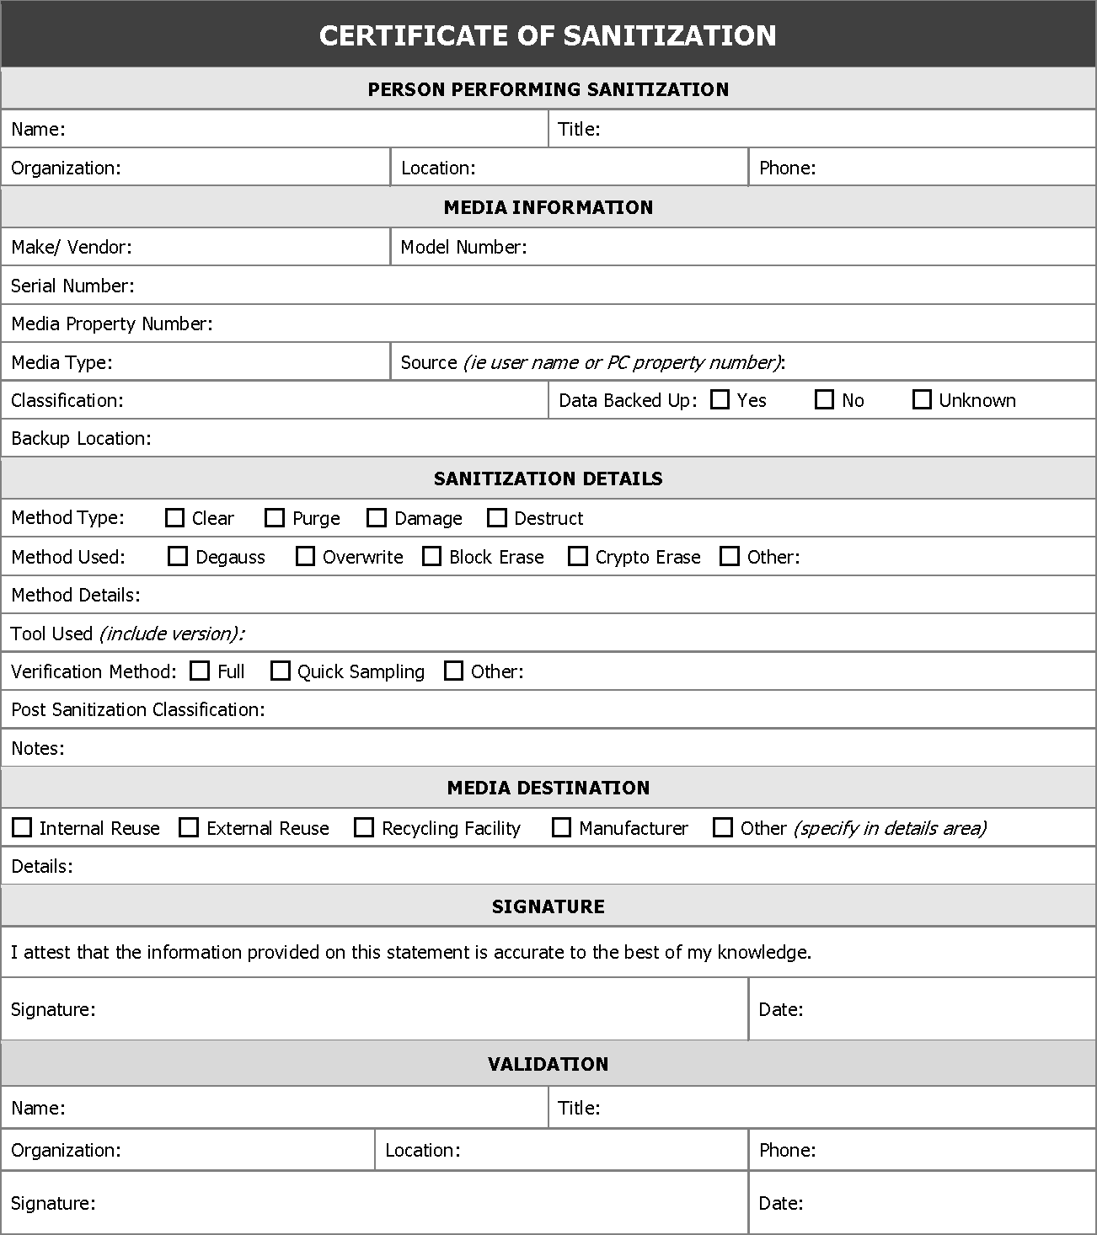
Source: Appendix G of NIST Special Publication (SP) 800-88 Revision 1, Guidelines for Media Sanitization, available at https://doi.org/10.6028/NIST.SP.800-88r1.
From Appendix G, “Sample ‘Certificate of Sanitization’ Form”:

This certificate is simply an example to demonstrate the types of information that should be collected and how a certificate might be formatted. An organization could alternatively choose to electronically record sanitization details, either through a native application or by using a form such as this one with an automated data transfer utility (such as a PDF form with a button to send the data to a database or email address). In the event that the records need to be referenced in the future, electronic records will likely provide the fastest search capabilities and best likelihood that the records are reliably retained.

