Federal Computer Security
Managers’ Forum (FCSM)
Google Group Overview and Resources

Questions:
Sec-forum@nist.gov
National Institute of Standards and Technology

Table of Contents
What is Google Groups 2
Where to Find the Google Groups Service 2
Joining a Group 3
How to Leave a Group or Update Information and Email Delivery Settings 4
Leave/Unsubscribe 4
Update Information and Email Delivery Settings 5
Read & Respond to Group Posts 6
Read and Respond to Posts Using the Web Interface 6
Read and Respond to Posts Using Email 6
Additional Resources 6

NOTE: All members currently subscribed to the Federal Computer Security Managers’ Forum (FCSM) distribution list will automatically be added as members to the FCSM Google Groups. Both mailing lists will continue to function to help with a seamless transition.
You do not need to re-request membership.

What is Google Groups
(Information from: https://gsuite.google.com/learning-center/products/groups/get-started/)

Google Groups makes it easy for groups of people—such as project teams, departments, or classmates—to communicate and collaborate. You can send an email to everyone in a group with one address, invite a group to an event, or share documents with a group. You can also create an online forum to discuss a popular technology or answer questions about a product.

You can use online and email-based groups with Google Groups to:
- Host discussions and make plans with a team, organization, or social group.
- Meet people with similar hobbies, interests, or backgrounds.
- Learn about a topic and join discussions on that topic.
- Create a Q&A forum for any topic, such as baking, health, or a task at work.
- Organize meetings, conferences, and social events.

Essentially, for users of the Federal Computer Security Managers’ Forum (FCSM), it will provide the same functionality (email listserv), but also include the ability to manage your subscription (e.g., how many emails you get a day/week) and search the archives!

The only change is instead of sending emails to FCSM@nist.gov, you will send them to FCSM@list.nist.gov OR you can post them from the Google Groups page.

Where to Find the Google Groups Service
- Go to Group Directory by entering this URL in your browser http://list.nist.gov - Enter Group name in Search text box (e.g., FCSM)
OR
You can also go directly to FCSM using one of the links below:
  - https://groups.google.com/a/list.nist.gov/forum/#!forum/FCSM
OR
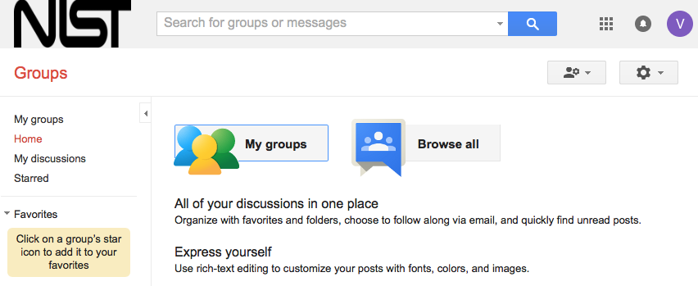
  - https://list.nist.gov/FCSM

Joining a Group
      - Sign in to Google Groups. Learn how to join if you don't have a Google Account.
NOTE: Please continue to use your work email address (.gov or .mil) for the FCSM Google Group. If you are already subscribed, you do not need to join again.
      - In the search box at the top, enter a subject "FCSM." Depending on what you search for, you might see a list of groups that meet the search criteria followed by a list of messages. To browse groups by category or region, click the “Browse all” Button.
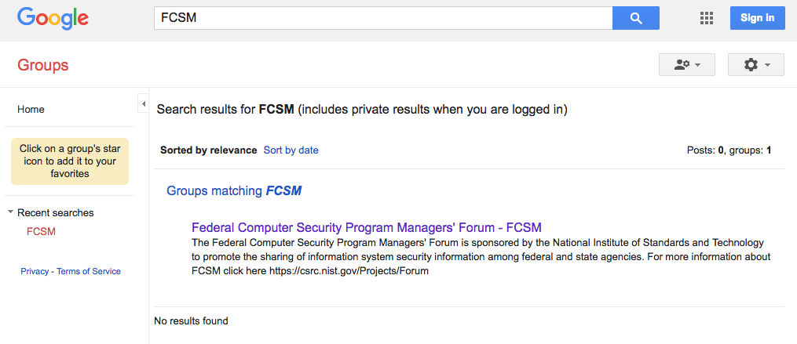
      - Click on a group name in the search results.
- To join a group, click Join group or Apply to join group. If a group is invite-only, you can ask to be invited by clicking Apply for membership. After you’ve been approved to joined the group, you’ll get an email letting you know. If you applied or contacted the owner, that means your application needs to be approved.
NOTE: FCSM is “invite-only.” An FCSM Administration will need to approve your request to join the group. This allows for only selected members to join the FCSM discussion.
Membership in the FCSM Google Group is limited to U.S. federal government employees only who participate in the management of their organization's computer security program and have a .gov or .mil email address. However, exceptions for designated contractors serving in higher positions such as ISSOs or CISOs have been made on a case-by-case basis as long as they have a .gov or .mil email address.

If you are already subscribed to FCSM@nist.gov, you do not need to create a Google Account. However, you'll need a Google Account to be able to manage your subscription options (e.g., number of emails you receive per week) and access the email archive.

To use these features with Google Groups, you can create a Google Account without changing your email address. (https://accounts.google.com/SignUpWithoutGmail)

How to Leave a Group or Update Information and Email Delivery Settings
You can stop receiving emails from a group by either leaving/unsubscribing the group, or changing your settings. If you unsubscribe from a group, you will no longer be a member, and you will stop receiving emails and lose the ability to view group messages. If you'd like to stay a member, but stop receiving emails, just change your email settings.

Leave/Unsubscribe
You can Leave/Unsubscribe from a group using any of these steps:

Option 1: Reply to an email from the group with REMOVE ME as the subject of your message.
Option 2: Send an email to FCSM+unsubscribe@list.nist.gov For example, if you want to leave the group “FCSM@list.nist.gov” you can remove yourself by sending a blank email to FCSM+unsubscribe@list.nist.gov.
Option 3: Send a blank email (no text in the body of the message) with the subject line: "Unsubscribe" to the group's email address
Option 4: Edit your settings.
- Open Google Groups.
- Click My Groups > name of the group you want to edit.
- In the upper-right corner, click My Settings > Leave this group

Update Information and Email Delivery Settings
Once you are logged in, you can update your information (name and email) and email delivery settings at any time.
- Go to My Settings
- Select “Membership and email settings”
- A pop up window will appear.
You can change your name and email for your membership. Please ensure you use your .gov or .mil email address or the NIST administrators will remove you from the list.
Select the your preferred email delivery frequency and “Save.”

Read & Respond to Group Posts

As a Google Groups user, one of the first things you might want to do is read and respond to group posts. Depending on how a group is configured (and your personal settings), you will be able to read and respond to posts either through the web interface and (optionally) using email.

Read and Respond to Posts Using the Web Interface
- Click on the 'My Groups' button on the Home screen. A list of all your subscribed groups appears.
- Click on a group name. The Topics screen appears with a list of all current topics. Notice that all of the unread posts for a topic are listed (in bold).
- Click on the topic you want to read. The first post in the topic (created when the topic was created) is displayed on top followed by all responses.
- Click on the Post reply arrows in the right corner by the time/date of the post. A reply field appears with a formatting toolbar at the top.
- Tip: Click on the Post reply button (or the red Post Reply) in the first post to reply to the original topic creator. Click on Reply to Author under "More message options" to reply to the poster through private email. Click on Forward under "More message options" to forward the post to an email address.
- (optional) Click the Quote original link to display the original message below your response.
- Type your reply in the reply field.
- (optional) Format your reply using options in the formatting toolbar.
- Click the Post button to reply to that post.

Read and Respond to Posts Using Email
- Click on the email in your inbox to see the message from the group
- Type a response to the email.
- Select reply (to respond only to the poster) or reply to all (to respond to the whole group). The response is posted.
- Email to FCSM@list.nist.gov (it used to be FCSM@nist.gov. This email will still be active as a redirect for a period of time. Please update your email to start using the FCSM@list.nist.gov)
Note: This process assumes that you have "Email" checked in the "How do you want to read this group?" section of my Membership settings (you are receiving an email for every post to the group), and that you are approved to send messages to the group. Some groups are set up as distribution lists and only Group Managers can send messages to the group. Other groups are discussion lists so all members can send messages to the groups.

Additional Resources
- Organize Favorite Groups
- More info on Joining a Group
- More info on Leaving a Group
- More info on Reading & Responding to Group Posts
- More info on Changing your Membership Settings
- Visit the Learning Center for quick start-up tips on Google Groups.
- Google Group New Features:
- http://www.ditoweb.com/blog/2012/07/google-groups-new-features-part-iii/
- Google Group Overview

