Beijing JN TASS Technology Co., Ltd.

TASS CPU Time Jitter RNG Entropy Source version 3.5.1

SP 800-90B Non-Proprietary Public Use Document

Document Version: 1.0
Document Date: 2026-06-02

Beijing JN TASS Technology Co., Ltd.
Rm.1110, Jin Ao International Building, No.17 Madian East Road, Haidian District
Beijing 100088, China

Prepared by:
atsec information security Corporation
4516 Seton Center Parkway, suite 250
Austin, TX 78759, USA

Table of Contents
1 Description 3
2 Security Boundary 3
3 Operating Conditions 4
4 Configuration Settings 5
5 Physical Security Mechanisms 5
6 Conceptual Interfaces 5
7 Min-Entropy Rate 5
8 Health Tests 5
9 Maintenance 6
10 User Verification 6
11 Vendor Permissions and Relationship 6

List of Tables
Table 1: Entropy source and operational environment information. 3
Table 2: Operating Conditions for each Operational Environment 4

List of Figures
Figure 1: Entropy Source Design 4

Description
The TASS CPU Time Jitter RNG Entropy Source version 3.5.1 is a non-physical entropy source implemented in multi-chip standalone embodiment. The noise generation of this entropy source is based on the tiny variations in the execution time of the same piece of code. The execution time of this piece of code is made unpredictable by the complexity of the different hardware components that comprise modern CPUs and the different internal states that the operating system can have at a certain point in time. The entropy source complies with IG D.J, D.K, and D.O.
The information about the entropy source described in this document is contained in Table 1. The noise source was tested under the assumption that its output is non-IID.
Table 1: Entropy source and operational environment information.
Characteristic | Description
Vendor | Beijing JN TASS Technology Co., Ltd.
Entropy source name | TASS CPU Time Jitter RNG Entropy Source
Standard, IGs | SP800-90B (2018)  IG D.J (2021-11-05), IG D.K (2026-04-16), IG D.O (2021-05-04)
Entropy category | Non-physical (NP)
Entropy source version | 3.5.1
Operational environment | TASS CloudHSM SJJ1528  Hardware version: S10000-II-B V2.00  Firmware version: H2.00.00  CPU: Intel® Xeon® 4410Y code name Intel Sapphire Rapids X86-64
Embodiment and type (module) | Multi-chip standalone hardware

Security Boundary
The boundary for this non-physical, software-based entropy source is the executable binary compiled from the C code that implements it (i.e., Userspace Standalone CPU Time Jitter RNG shared library).
Figure 1 depicts the overall design of the entropy source and its core operations.
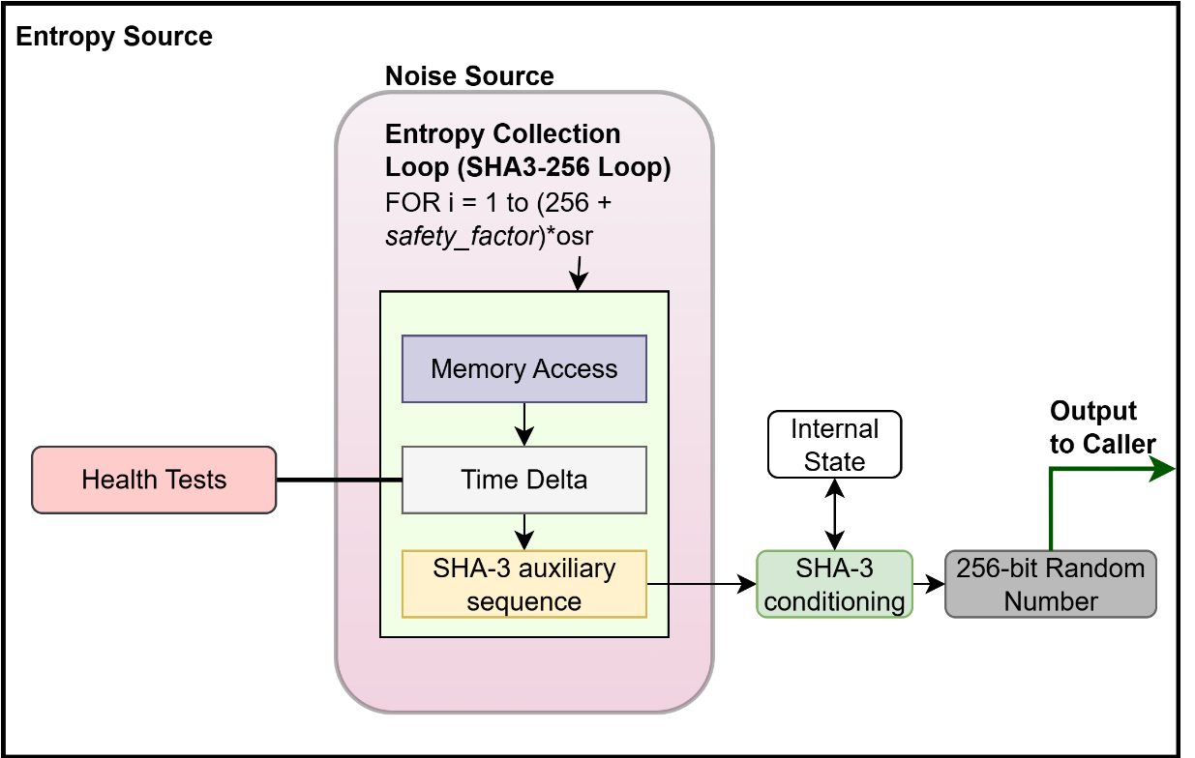
Figure 1: Entropy Source Design
The noise source is implemented by collecting and accumulating variances of the execution time of a defined set of instructions. The time jitter of the execution time is measured over time variances of variable memory accesses and variances in the execution time of a defined set of instructions, which includes an implementation of SHA3-256.
If the Repetition Count Test (RCT) or the Adaptive Proportion Test (APT) health tests fail, the noise data is discarded, the entropy source halts without outputting any data, and a failure code is returned to the caller.

Operating Conditions
The noise source is non-physical, and thus the operating conditions are inherited from the operational environment in which the entropy source is installed, as shown in Table 2.
Table 2: Operating Conditions for each Operational Environment
Manufacturer/Model | Temperature | Voltage | Clock Speed | Cache Sizes
TASS CloudHSM SJJ1528 | 0 °C - 45 °C | 190 - 250 VAC, 60 Hz | 2.0 GHz | L1i: 384 KB  L1d: 576 KB  L2: 20 MB  L3: 30 MB

Configuration Settings
The TASS CPU Time Jitter RNG Entropy Source is part of the TASS CloudHSM SJJ1528. The user does not have access to configure TASS CPU Time Jitter RNG Entropy parameters.

Physical Security Mechanisms
The noise source is non-physical.
The physical security mechanisms apply to the TASS CloudHSM SJJ1528 in which the entropy source is installed, and thus the entropy source inherits those mechanisms from FIPS 140-3 Security Level 3 requirements, including opaque steel chassis, unique tamper seals applied around the module, and tamper-response switches protected removable cover.

Conceptual Interfaces
The entropy source provides the following interfaces:
- jent_entropy_init(): Initializes the entropy source context, including the configuration of the CPU timer or the internal timer.
- jent_read_entropy(): Obtains conditioned entropy for the caller. This is the main function of the entropy source, the one that shall be used to request entropy data. This interface corresponds to the GetEntropy() conceptual interface from SP800-90B.
- jent_entropy_collector_free(): zeroizes and frees the given entropy collector instance.

Min-Entropy Rate
The entropy source provides 256 bits of entropy per 256-bit conditioned output block (i.e., full entropy).

Health Tests
The entropy source implements the following continuous health tests:
- Repetition Count Test conforming to SP 800-90B section 4.4.1.
  - Intermittent cutoff value 𝐶_{𝑖} = 91
  - Permanent cutoff value 𝐶_{𝑝} = 181
- Adaptive Proportion test conforming to SP 800-90B section 4.4.2.
  - 𝑊 = 512
  - Intermittent cutoff value 𝐶_{𝑖} = 459
  - Permanent cutoff value 𝐶_{𝑝} = 479
- Stuck (Non-Permanent) Test: The Stuck Test computes the first, second and third discrete derivatives of the time value that will be processed by SHA3-256. If any of these derivatives are zero, then the received time delta is considered stuck. In this case the input state to SHA3-256 is not updated, and the entropy value is not counted. The stuck test then triggers the RCT for further processing. The second derivative is in fact the RCT itself.
- Lag Predictor Test: The goal of this test is to detect a failure mode in which the outputs may become mostly deterministic. In essence, this test constructs a scoreboard and tracks the number of times that a subpredictor was correct. The subpredictor that scored the most correct predictions is used to predict the next value of a series. The lag predictor test is configured in this entropy source with the following parameters:
  - 𝛼 = 2⁻²²
  - Window size: 131072
  - Lag history size: 8
  - Global cutoff = 104761
  - Local cutoff = 111
The continuous-health tests are applied to each new sample obtained from the noise source. Whenever a failure is detected during the health testing specifically for the RCT and APT, entropy data is not returned to the caller; instead, a failure code is returned to enable the caller to acknowledge the failure. In the case of a permanent failure, the module containing the entropy source will enter the error state, and all ports and interfaces to the device are disabled. Upon return of the permanent failure code, the caller shall attempt to reset or reboot the entropy source or return an error to its own operator. The stuck test is considered non-permanent, as positive stuck tests will be registered but will not immediately halt the entropy source.
Startup tests conduct the same set and parameters of the continuous health tests on 1124 samples of noise data. The data is discarded after the startup tests have completed successfully.
On-demand health tests of the noise source may be performed by rebooting the operational environment, which results in the immediate execution of the start-up tests. Typically, this entropy source designed for user space cannot be reloaded without restarting the executable. Similarly, the data used for the on-demand health tests are discarded after successful completion.

Maintenance
There are no maintenance requirements.

User Verification
The TASS CPU Time Jitter RNG Entropy Source is part of the TASS CloudHSM SJJ1528. The user could verify the hardware and firmware version via the “Show module name and version” service. See the TASS CloudHSM SJJ1528 Non-Proprietary Security Policy for more information.
Raw noise data is not available for the module’s user; the user must rely on the health tests to detect any drops in entropy.

Vendor Permissions and Relationship
This entropy source validation is marked as “Reuse restricted to vendor”.

